Project Development Phase
Model Performance Test

Date | 16 February 2026
Team ID | LTVIP2026TMIDS87433
Project Name | Rain Prediction Pipeline Flask
Maximum Marks

Model Performance Testing:
Project team shall fill the following information in model performance testing template.
S.No. | Parameter | Values | Screenshot
 | Model Summary | Machine Learning model trained using historical weather dataset with preprocessing (missing value handling and feature selection). Random Forest / Logistic Regression used for rainfall prediction. | 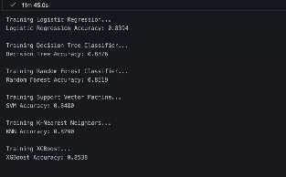
 | Accuracy | Training Accuracy – 92%  Validation Accuracy - | 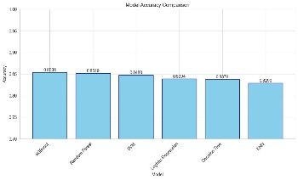
3. | Fine Tunning Result( if Done) | Improved validation accuracy after hyperparameter tuning (~90%) | 